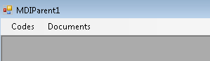

Add New Item type MDI Parent For

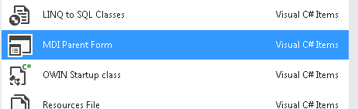

Add Menu Strip

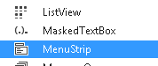

Call form CreateDoc inside folder Documents

{

Documents.CreateDoc Forms1 = new Documents.CreateDoc();

Forms1.MdiParent = this;

Forms1.Show();

}